Assignment - 1
tracker.py
- Author : Aryan
- Roll NO : 2501940066
- Date : 11-11-25
- Course : MCA(AI/ML)
- Assignment : Command-Line Attendance Tracker
- Purpose : Simple attendance tracker that collects student names and check-in times,
validates input, prevents duplicates, shows a formatted summary, optionally calculates absentees, and can save the report to a file.

1) Complete tracker.py (copy this into attendance_tracker/tracker.py

import re
from datetime import datetime

TIME_FORMAT = "%I:%M %p" # example: 09:15 AM

def is_valid_time(tstr: str) -> bool:
"""Validate time string is in format HH:MM AM/PM (e.g. 09:15 AM)."""
try:
datetime.strptime(tstr.strip(), TIME_FORMAT)
return True
except Exception:
return False

def get_nonempty_input(prompt: str) -> str:
"""Prompt until non-empty string returned."""
while True:
s = input(prompt).strip()
if s:
return s
print("Name cannot be empty. Please enter a valid name.")

def get_valid_time_input(prompt: str) -> str:
"""Prompt until a valid timestamp is entered in the expected format."""
while True:
t = input(prompt).strip()
if not t:
print("Timestamp cannot be empty. Please re-enter time in format HH:MM AM/PM (e.g. 09:15 AM).")
continue
if is_valid_time(t):
# Normalize to standard format (e.g. 9:5 AM -> 09:05 AM)
dt = datetime.strptime(t, TIME_FORMAT)
return dt.strftime(TIME_FORMAT)
else:
print("Invalid time format. Use HH:MM AM/PM (e.g. 09:15 AM). Try again.")

def print_summary(attendance: dict, total_strength: int | None = None):
"""Prints a neat attendance summary table."""
print("\nAttendance Summary")
print("-" * 40)
header_name = "Student Name"
header_time = "Check-in Time"
print(f"{header_name:20s} {header_time}")
print("-" * 40)
for name, t in attendance.items():
print(f"{name:20s} {t}")
print("-" * 40)
total_present = len(attendance)
print(f"Total Students Present: {total_present}")
if isinstance(total_strength, int):
total_absent = max(0, total_strength - total_present)
print(f"Total Students (Class Strength): {total_strength}")
print(f"Total Absent: {total_absent}")

def save_report(attendance: dict, total_strength: int | None = None):
"""Save attendance to attendance_log.txt."""
filename = "attendance_log.txt"
now = datetime.now().strftime("%Y-%m-%d %H:%M:%S")
with open(filename, "a", encoding="utf-8") as f:
f.write(f"Attendance Report - Generated on: {now}\n")
f.write("-" * 60 + "\n")
f.write(f"{'Student Name':30s} {'Check-in Time'}\n")
f.write("-" * 60 + "\n")
for name, t in attendance.items():
f.write(f"{name:30s} {t}\n")
f.write("-" * 60 + "\n")
f.write(f"Total Present: {len(attendance)}\n")
if isinstance(total_strength, int):
f.write(f"Total Strength: {total_strength}\n")
f.write(f"Total Absent: {max(0, total_strength - len(attendance))}\n")
f.write("\n")
print(f"Attendance saved to '{filename}'.")

def main():
print("Welcome to the Command-Line Attendance Tracker")
print("This tool records student names with check-in times, validates entries, and can save a report.\n")

# number of entries to record
while True:
num_entries_raw = input("How many entries would you like to record? ").strip()
if num_entries_raw.isdigit() and int(num_entries_raw) >= 0:
num_entries = int(num_entries_raw)
break
print("Please enter a non-negative integer for the number of entries.")

attendance = {}

for i in range(num_entries):
print(f"\nEntry {i+1} of {num_entries}:")
# name input with validation (blank-check)
name = get_nonempty_input(" Student name: ")
# duplicate check
if name in attendance:
print(" This name is already recorded. Duplicate entries are not allowed. Skipping this entry.")
continue
# time input with validation
time_str = get_valid_time_input(" Check-in time (HH:MM AM/PM, e.g. 09:15 AM): ")
attendance[name] = time_str

# Optional enhancement: ask total class strength for absentee calculation
total_strength = None
while True:
resp = input("\nDo you want to provide total class strength to compute absentees? (y/n): ").strip().lower()
if resp in ("y", "n"):
break
print("Please enter 'y' or 'n'.")
if resp == "y":
while True:
ts_raw = input("Enter total number of students in the class: ").strip()
if ts_raw.isdigit() and int(ts_raw) >= 0:
total_strength = int(ts_raw)
break
print("Enter a non-negative integer for class strength.")

# Print summary
print_summary(attendance, total_strength)

# Bonus: save to file
while True:
save_resp = input("\nDo you want to save the attendance report to file? (y/n): ").strip().lower()
if save_resp in ("y", "n"):
break
print("Please enter 'y' or 'n'.")
if save_resp == "y":
save_report(attendance, total_strength)
else:
print("Report not saved. You can run the program again to save when ready.")

if __name__ == "__main__":
main()

2) What the script covers (mapping to PDF tasks)
- Task 1 (setup & header): Script header comment + welcome message.
- Task 2 (input & data collection): Prompts for number of entries and loops to collect Student name and Check-in time storing them in a dictionary.
- Task 3 (data validation):
  - Rejects blank names with message "Name cannot be empty."
  - Re-prompts until a valid timestamp in HH:MM AM/PM is provided.

  - Prevents duplicate names (skips duplicate entry and warns).
- Task 4 (attendance summary): Prints a formatted table using f-strings and alignment; shows total present.
- Task 5 (absentee validation): Optionally asks for class strength and prints total absentees.
- Task 6 (bonus: save to file): Optionally saves attendance_log.txt with timestamps and counts; uses current datetime.

3) Sample runs

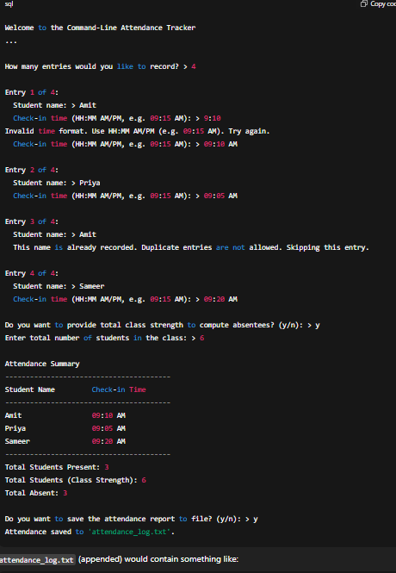

attendance_log.txt (appended) would contain something like

